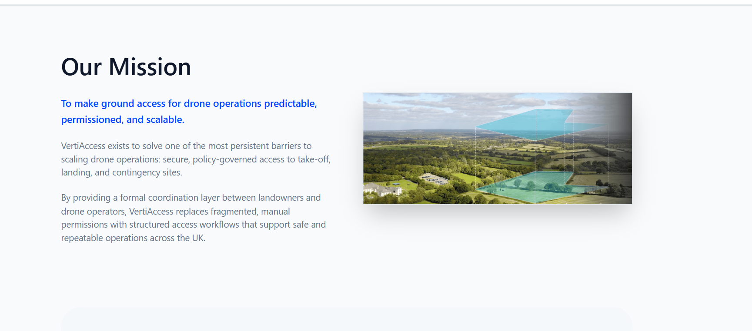

Replace text in the About Us Section:
Top Blue Text: Enabling fast, reliable, and scalable access to ground infrastructure for drone operations.
Main Text: VertiAccess exists to solve one of the most persistent barriers to scaling drone operations: secure, policy-governed access to take-off, landing, and contingency sites. We enable this by connecting operators with a network of verified take-off, landing, and emergency recovery sites across private land, estates and parks, drone ports, and aviation facilities.
By providing coordination at an operational layer between landowners and drone operators, VertiAccess replaces fragmented permissions with structured workflows that enable safe and scalable drone operations across the UK.
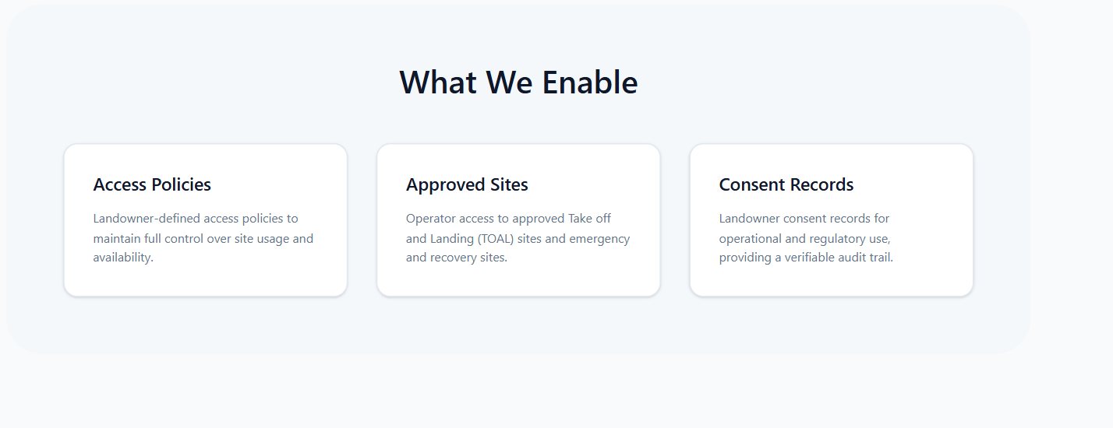
Replace Approved Sites to:
Verified Sites: Access to a network of verified take-off and landing (TOAL) and emergency recovery sites across trusted landowners and infrastructure providers.
Digital Operational Permission: Structured approvals that provide auditable evidence of land access for operational and regulatory use.
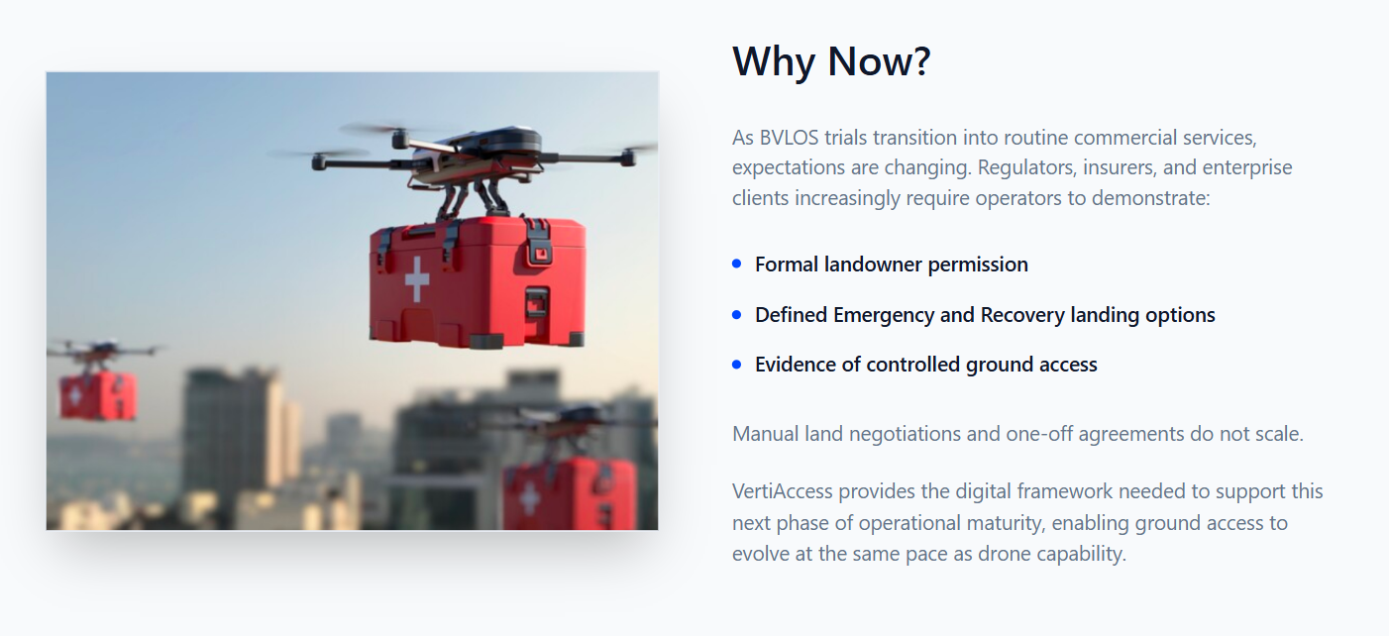

As BVLOS trials transition into routine commercial services, expectations are changing. Regulators, insurers, and enterprise clients increasingly require operators to demonstrate:
- Fast and Formal landowner permission
- Defined Emergency and Recovery landing options
- Evidence of controlled ground access
Manual land negotiations and one-off agreements do not scale.
VertiAccess provides an operational framework that supports the next phase of operational and regulatory maturity, enabling scalable and coordinated access to ground infrastructure across the ecosystem.

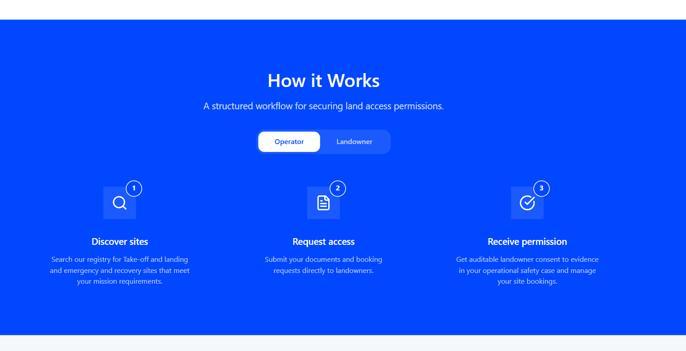

Top Sub-heading: A structured workflow for accessing ground infrastructure at scale.
Third Box:
Receive operational access
Get approved access to landowner sites for your operational scenarios, with auditable confirmation to support regulatory applications and manage bookings.

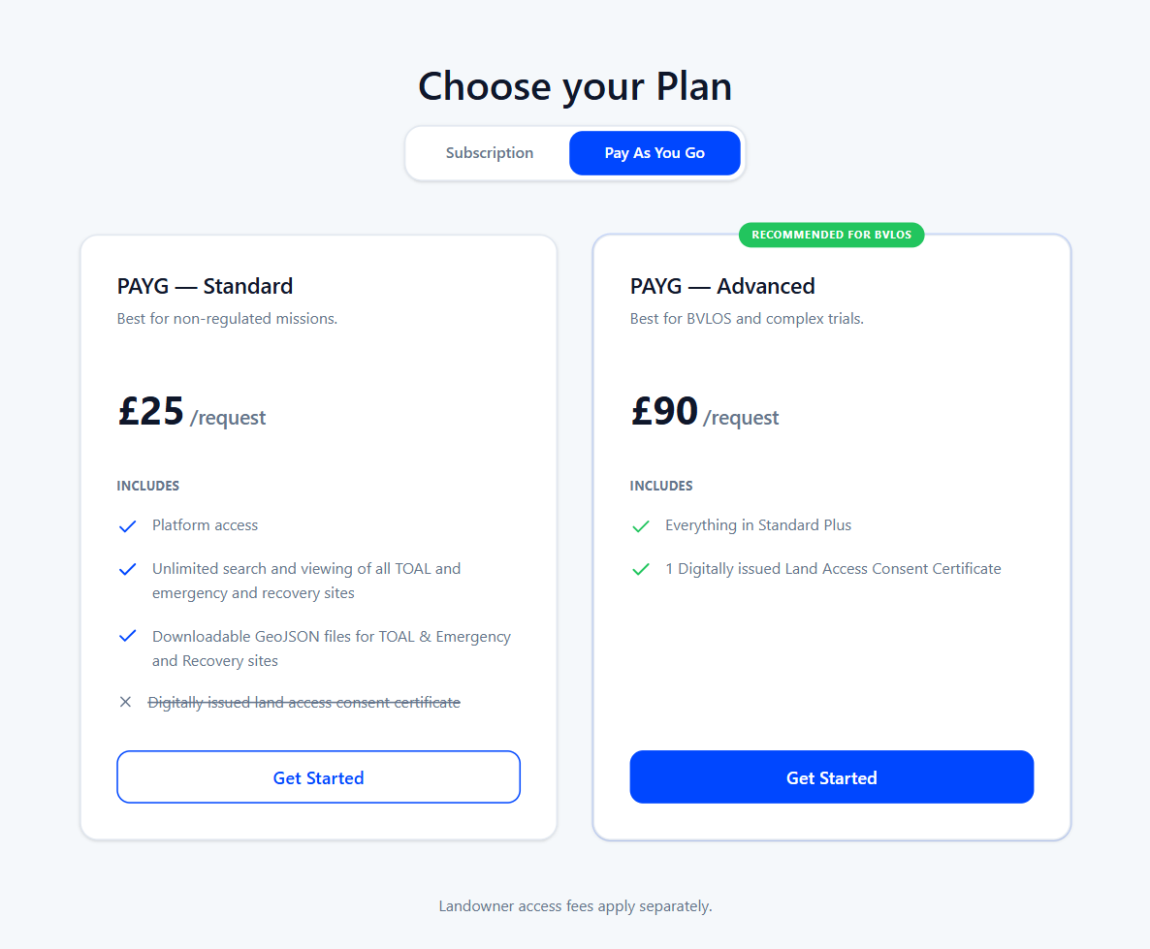

Remove PAYG- Standard Completely and centre PAYG – Advance.

Modify PAYG-Advance to:

PAYG - Default
£90 / request
Includes:
- Access to VertiAccess platform
- Search and discovery of all sites
- Submit operational requests to landowners
- Access lifecycle management
- Auditable operational access record

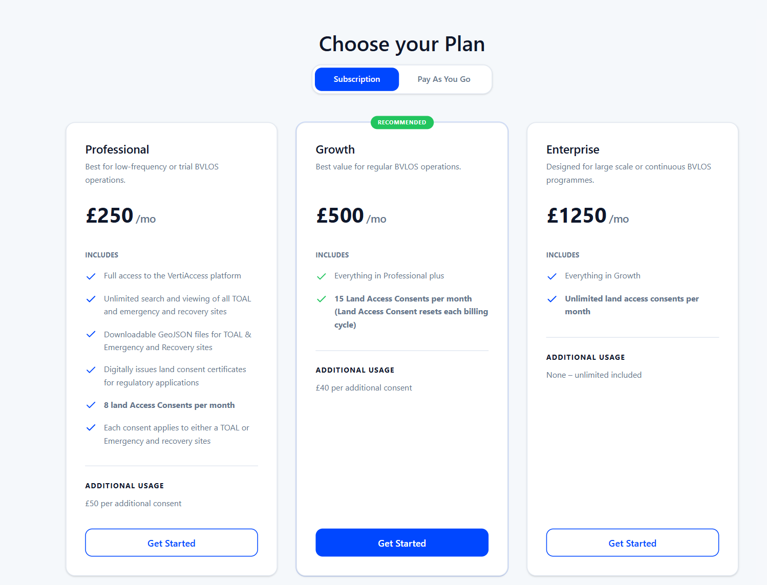

Professional — £250/month
Best for trials or low-frequency BVLOS
Includes:
- Access to VertiAccess platform
- Search and discovery of all sites
- Submit operational requests to landowners
- Access lifecycle management
- Auditable operational access record
- Up to 5 bookings per month included
Additional Usage
£50 per additional access request

Growth — £500/month (Recommended)
Best value for regular BVLOS operations
Includes:
- Everything in Professional
- Up to 15 bookings per month included
Additional Usage
£30 per additional access request

Enterprise — £1250/month
Designed for large-scale or continuous operations
Includes:
- Everything in Growth
- Unlimited access requests
- Flexible cancellation terms for approved land access
- API Integration with third-party system

